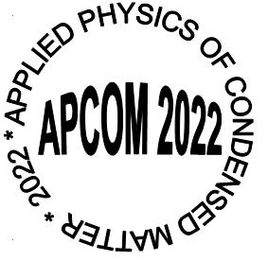

APPLICATION FORM

(Please email to the chairman of the organizing committee jan.vajda@stuba.sk or to the conference administrator apcom@elf.stuba.sk before January 31, 2022)
Mr. / Lady / Miss
(Please cross out inappropriate options)
The main content areas are the following:

- New materials and structures (incl. nanostructures and thin films), their analysis and specific applications
- Physical properties and structural aspects of solid materials and their influencing
- Optical phenomena in materials, photovoltaics and photonics, new principles in sensors and detection methods, applied optics and optical communications
- Nuclear science and technology (with emphasis on the influence of irradiation on physical properties of materials and radiation detection)
- Computational physics and theory of physical properties of matter
- Biophysics and interdisciplinary physics of condensed matter
- Current Successes in the Photo-emission and Electron Microscopy

Please cross out inappropriate options or highlight appropriate option

I ask for single room

yes no only if possible

I would like to present my contribution in the form of poster

yes no
Title: Prof./Dr./Dipl.Eng./PhD.Student/Student
Name and surname:
Institution:

Contact address

Postal Code: …Country:………………….
Tel.: Email:………………………….
Address for exact issue of an invoice (please consult it with your economy department):

VAT No. (IČ DPH):………………………………
I intend to submit the paper for oral presentation with preliminary title:

I propose to incorporate my contribution into the main content area No. (please cross out inappropriate options or highlight appropriate option)
1 2 3 4 5 6 7

Date: ………………….Signature:…………………

http://kf.elf.stuba.sk/~apcom/

